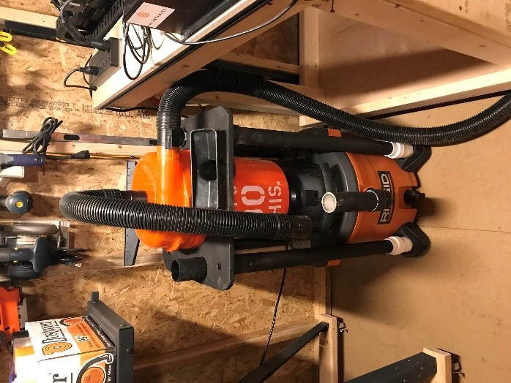
The Dust Topper can only be purchased online - not in stores.
https://www.homedepot.com/p/Dustopper-High-Efficiency-Dust-Separator-12-in-dia-with-2-5-in-hose-36-in-long-HD12/302643445
14 Gal Rigid Shop Vac – In Store
https://www.homedepot.com/p/RIDGID-14-Gal-6-0-Peak-HP-Wet-Dry-Vac-WD1450/100081216
5 Gal basic Bucket. – In Store
https://www.homedepot.com/p/The-Home-Depot-5-Gal-Homer-Bucket-05GLHD2/100087613

Supply List:
Qty 1 - 2" Dia PVC x 24 inch's long.
Qty 4 – 1 ½ " Dia PVC x 48 inch's long.
Qty 4 - 2" to 1 ½ " Dia PVC reducer.
Qty 4 - 1 1/2 " Dia PVC End Caps.
Qty 4 - 5/16- 18 bolts, (8) washers and n (4) nuts.
Qty 1 - Can of Flat Black Spray Paint (Cheap is fine).

Work Piece Cut Order…
Clamp outer edges first - cut center.
Clamp thru Center hole - remove profile clamps
Cut outer Profile
Clamp outer profile again.
Remove inner clamps.
Cut Hose Attachment holes.
Dimple cut Center holes for end caps. – Manually Drilled once dimpled by xcarve workpiece #3.

